***TABLE OF CONTENTS***

1) Customer

2) Category

3) Accessories

4) Food

5) Cloth

6) Size

7) Color

8) Salesman

9) Store

10) Manager

11) Manage

12) Invoice

13) Purchase

***Business And System Summary:***

SUPER SHOP MANAGEMENT SYSTEM (SSMS) is going to be launched as a partnership of super shop business.

The company owns and operates an industrial plant and is engaged on the making of business food product, Accessories items, Cloths.

Super shop has made our life easy. It has also saved our labor cost due to self service system. Super shop market has also large turn over. It also keeps variety of goods for this reason everybody can get benefit from this. Super shop deals in commodities. One important facilities of super shop is self services. Here every activities held by computer.

Super shop management system helps us to understand the vital elements of our business and gives us the most vital elements regarding our trends.

***Business Environment:***

The project SUPER SHOP MANAGEMENT SYSTEM (SSMS) is based on the database, object oriented and networking technique. As there are many areas where we keep records in database for which we are using oracle 10g express edition software which is one of the best and easiest software which is an Object oriented Programming and has connectivity with ORACLE. It is a web based application in which number of clients can also access with a server.

***HARDWARE:***

**Processor :** Inter corei5

**Memory :** 8GB RAM

**Cache Memory :** 10MB

**Hard Disk :** 500 GB

**Printer :** Leaser Printer

***Software:***

**Operating System :** Windows 8.1(Home Premium)

**Back –End :** ORACLE 10g

***Project Objective:***

This term contains introduction to the super shop reservation system. It is computerized. People can easily buying their product in the super shop and it is self service.

At present in our country there are many super shops. The most common thing of super shop is people get every things in the shop and don’t need to go outside.

The aim of our project is to provide better goods to the customers in better way. Technology makes people life easier. As we know differences in consumer needs, personalities, wants, goods, make our shopping pattern different.

1**.  All sales activity is properly manage in super shop.**

2. **User will consume less time in calculation and the whole procedure will be completed within a fraction of seconds.**

3. **Keeping the records of the sales frequently.**

***Technical Summary:***

Super shop management system is a computerized system designed and programmed to provide better services. In the super store we should have all the details of goods, foods, dress, vegetables, fruits etc. To design the database of this system we have to design the data base which will have all the information about super shop like purchase details, payment system, product details etc. There will also including Manager, Salesman, Customer, Store, Category, Product, Invoice. The project outlines all the process followed to come up with the software that is from analysis to testing the system.

***ER Diagram***

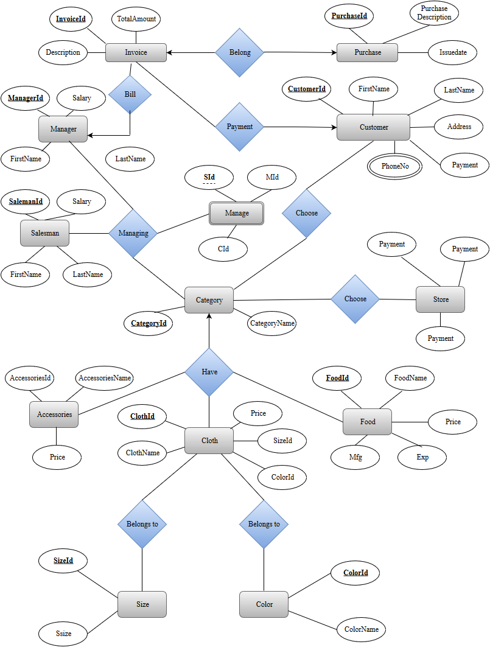

***Normalization***

|  |  |  |  |  |  |
| --- | --- | --- | --- | --- | --- |
| CustId | CustName | Phone | Address | CategoryId | CategoryName |

**Choose:**

|  |  |  |  |  |  |  |
| --- | --- | --- | --- | --- | --- | --- |
| CustId | FirstName | LastName | Phone | Address | CategoryId | CategoryName |

1NF:

2NF:

**Customer:**

|  |  |  |  |  |  |
| --- | --- | --- | --- | --- | --- |
| CustId | FirstName | LastName | Phone | Address | CategoryId |

**Category:**

|  |  |
| --- | --- |
| CategooryId | CategoryName |

3NF:

No Transative Dependency

**Product:**

|  |  |  |  |  |  |  |  |  |  |
| --- | --- | --- | --- | --- | --- | --- | --- | --- | --- |
| CategoryId | CategoryName | ClothName | Color | Price | size | FoodName | Mfg | Exp | AccessoriesName |

1NF:

* Color and size are multivalued.So, we will take data in different rows.

|  |  |  |  |  |  |  |  |  |  |
| --- | --- | --- | --- | --- | --- | --- | --- | --- | --- |
| CategoryId | CategoryName | ClothName | Color | Price | size | FoodName | Mfg | Exp | AccessoriesName |

|  |  |  |  |  |  |  |  |  |  |  |  |  |
| --- | --- | --- | --- | --- | --- | --- | --- | --- | --- | --- | --- | --- |
| CategoryId | CategoryName | ClothId | ClothName | Color | Size | Price | FoodId | FoodName | Mfg | Exp | AccessoriesId | AccessoriesName |

2NF:

Category:

|  |  |
| --- | --- |
| CategoryId | CategoryName |

Food:

|  |  |  |  |  |  |
| --- | --- | --- | --- | --- | --- |
| FoodId | FoodName | Mfg | Exp | Price | CategoryId |

Cloth:

|  |  |  |  |  |  |
| --- | --- | --- | --- | --- | --- |
| ClothId | ClothName | Color | Size | Price | CategoryId |

**Accessories:**

|  |  |  |  |
| --- | --- | --- | --- |
| AccessoriesId | AccessoriesName | Price | CategoryId |

3NF:

Category:

|  |  |
| --- | --- |
| CategoryId | CategoryName |

Food:

|  |  |  |  |  |  |
| --- | --- | --- | --- | --- | --- |
| FoodId | FoodName | Mfg | Exp | Price | CategoryId |

Cloth:

|  |  |  |  |  |  |
| --- | --- | --- | --- | --- | --- |
| ClothId | ClothName | ColorId | SizeId | Price | CategoryId |

Color:

|  |  |
| --- | --- |
| ColorId | ColorName |

Size:

|  |  |
| --- | --- |
| SizeId | Ssize |

Accessories:

|  |  |  |  |
| --- | --- | --- | --- |
| AccessoriesId | AccessoriesName | Price | CategoryId |

Store:

|  |  |  |  |  |
| --- | --- | --- | --- | --- |
| CategoryId | CategoryName | StoreId | StoreName | StoreLocation |

1NF:

Already in 1NF.

2NF:

Category:

|  |  |  |
| --- | --- | --- |
| CategoryId | CategoryName | StoreId |

Store:

|  |  |  |
| --- | --- | --- |
| StoreCode | StoreName | StoreLocation |

3NF:

Already in 3NF.

Manage:

|  |  |  |  |  |  |  |
| --- | --- | --- | --- | --- | --- | --- |
| CategoryId | CategoryName | SalesmanId | SalesmanName | ManagerId | ManagerName | salary |

1NF:

|  |  |  |  |  |  |  |  |  |
| --- | --- | --- | --- | --- | --- | --- | --- | --- |
| CategoryId | CategoryName | SalesmanId | S_firstName | S_lastName | ManagerId | M_firstName | M_lastName | salary |

2NF:

Category:

|  |  |
| --- | --- |
| CategoryId | CategoryName |

Salesman:

|  |  |  |  |
| --- | --- | --- | --- |
| SalesmanId | FirstName | LastName | Salary |

Manager:

|  |  |  |  |
| --- | --- | --- | --- |
| ManagerId | FirstName | LastName | Salary |

Manage:

|  |  |  |
| --- | --- | --- |
| SalesmanId | ManagerId | CategoryId |

3NF:

Already in 3NF

Bill:

|  |  |  |  |  |  |
| --- | --- | --- | --- | --- | --- |
| ManagerId | ManagerName | salary | invoiceId | description | totalAmount |

1NF:

|  |  |  |  |  |  |  |
| --- | --- | --- | --- | --- | --- | --- |
| ManagerId | firstName | lastName | salary | invoiceId | description | totalAmount |

2NF:

Invoice:

|  |  |  |  |
| --- | --- | --- | --- |
| invoiceId | description | totalAmount | ManagerId |

Manager:

|  |  |  |  |
| --- | --- | --- | --- |
| ManagerId | firstName | lastName | salary |

3NF:

Already in 3NF

Purchase & Payment:

|  |  |  |  |  |  |  |  |  |  |  |
| --- | --- | --- | --- | --- | --- | --- | --- | --- | --- | --- |
| CustId | CustName | Phone | Address | Payment | invoiceId | description | totalAmount | PurchaseId | Pur_description | IssueDate |

1NF:

|  |  |  |  |  |  |  |  |  |  |  |  |
| --- | --- | --- | --- | --- | --- | --- | --- | --- | --- | --- | --- |
| CustId | firstName | lastName | Phone | Address | Payment | invoiceId | description | totalAmount | PurchaseId | Pur_description | IssueDate |

2NF:

Customer:

|  |  |  |  |  |  |
| --- | --- | --- | --- | --- | --- |
| CustId | firstName | lastName | Phone | Address | Payment |

Invoice:

|  |  |  |
| --- | --- | --- |
| invoiceId | description | totalAmount |

Purchase:

|  |  |  |  |
| --- | --- | --- | --- |
| PurchaseId | Pur_description | IssueDate | invoiceId |

3NF:

Already in 3NF

***TABLE DESCRIPTION***

Table : Customer

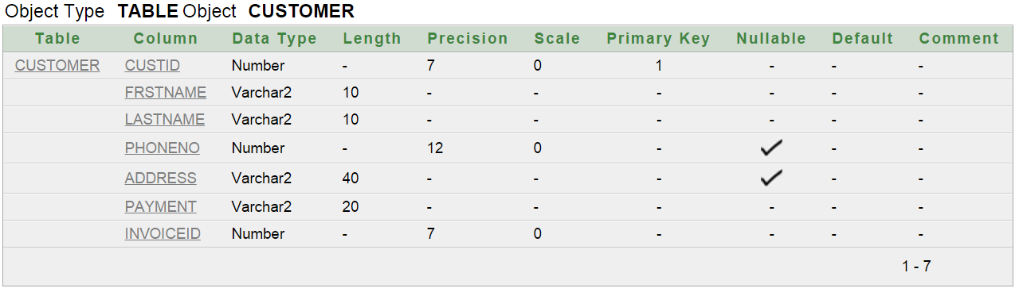

Table : Category

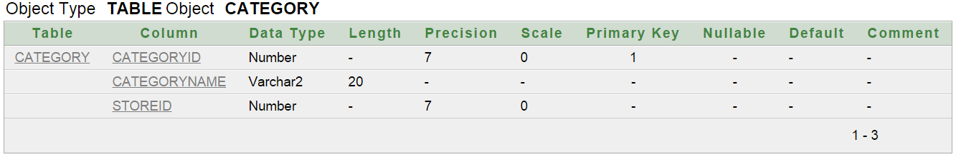

Table : Accessories

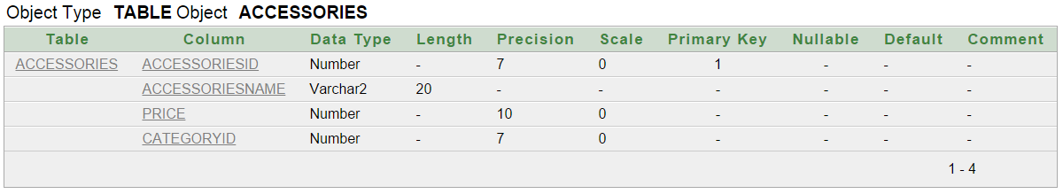

Table : Food

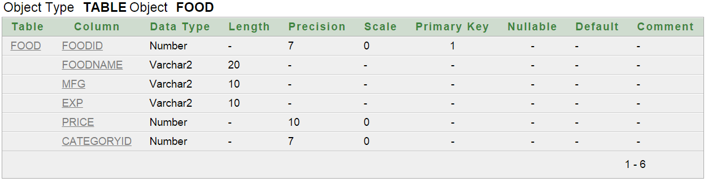

Table : Cloth

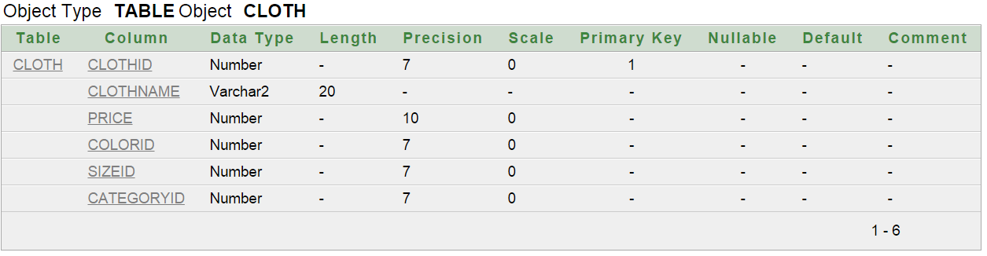

Table : ClothSize

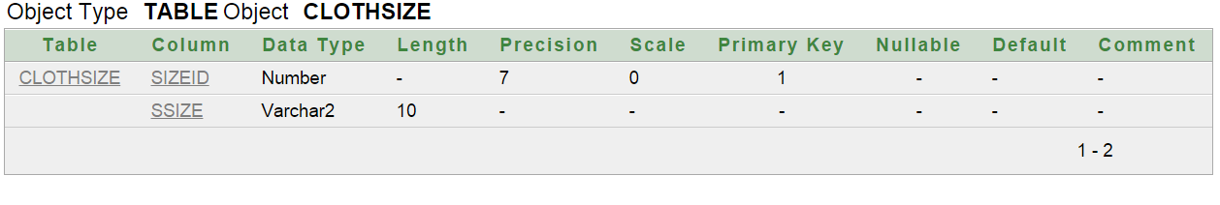

Table : Color

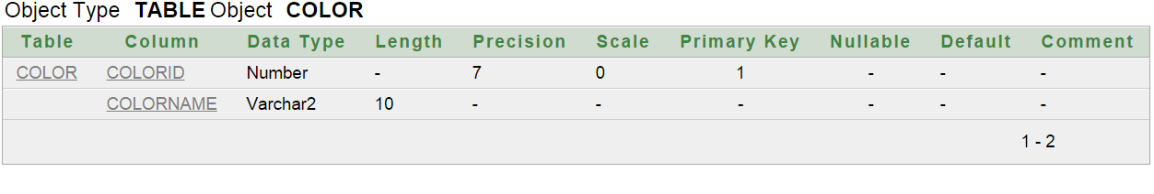

Table : Salesman

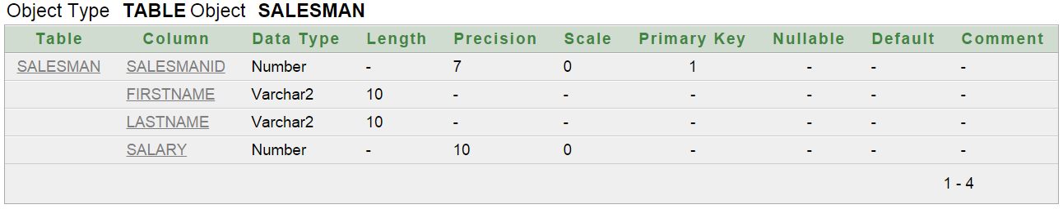

Table : Store

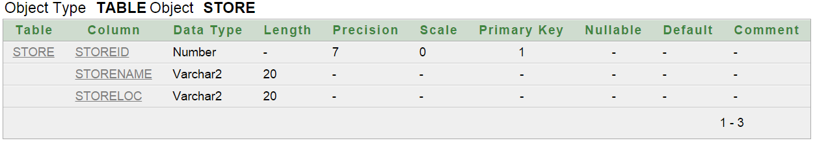

Table : Manager

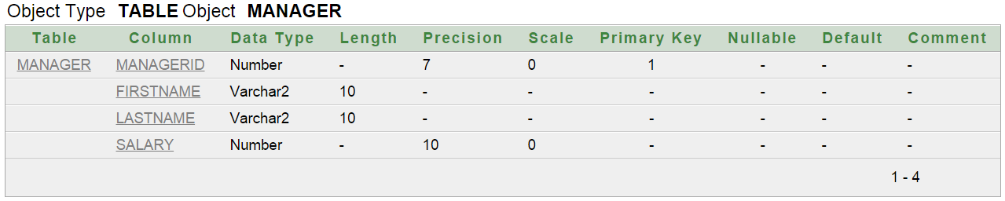

Table : Manage

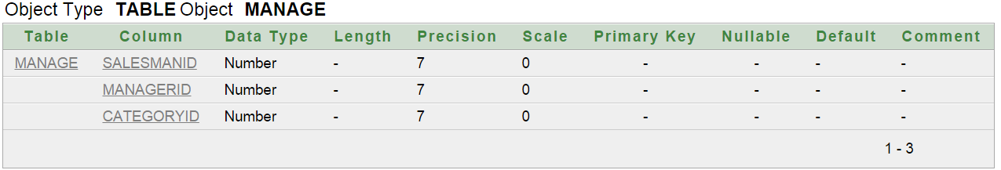

Table : Invoice

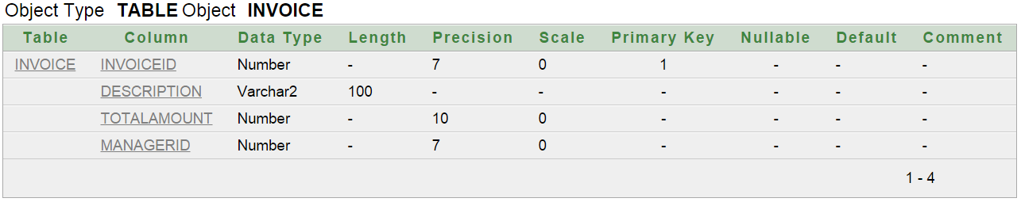

Table : Purchase

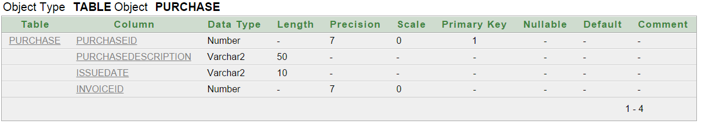

***TABLE DATA***

Customer Table:

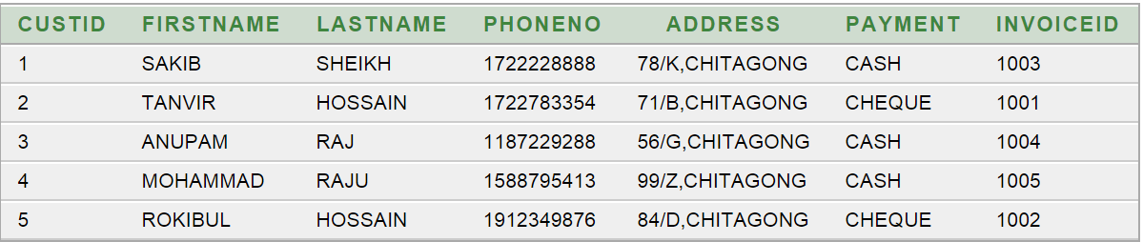

Category Table:

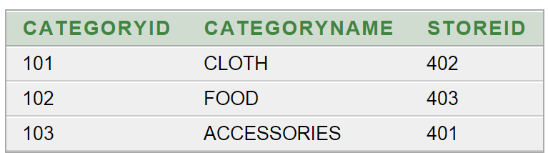

Accessories Table:

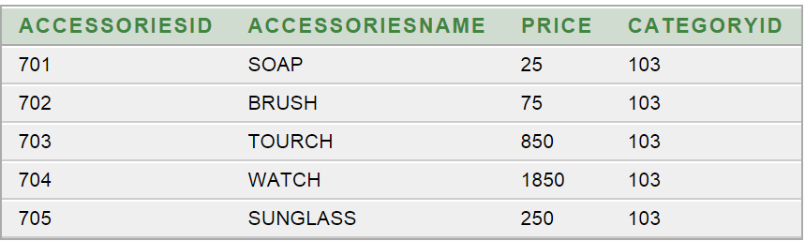

Food Table:

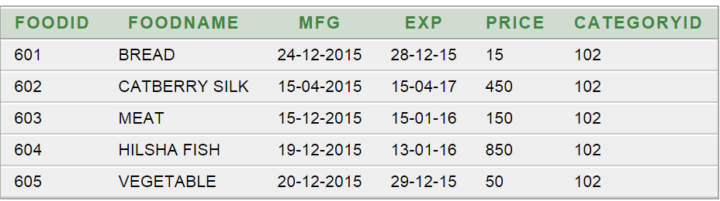

Cloth Table:

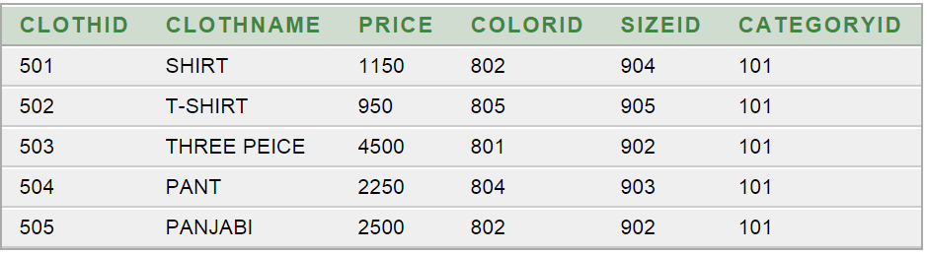

ClothSize Table:

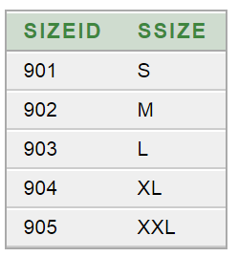

Color Table:

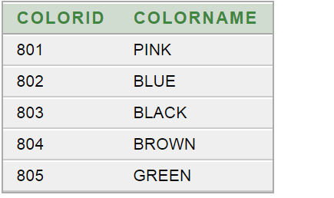

Salesman Table:

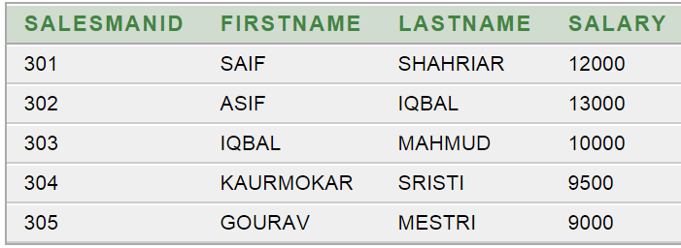

Store Table:

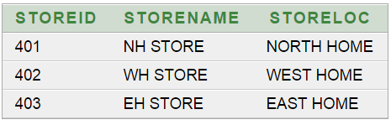

Manager Table:

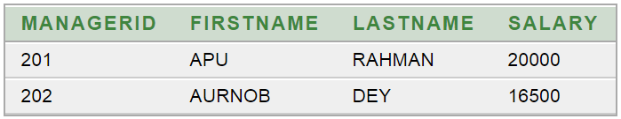

Manage Table:

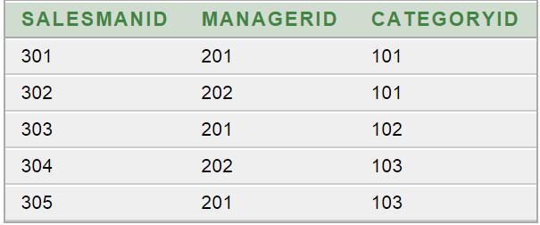

Invoice Table:

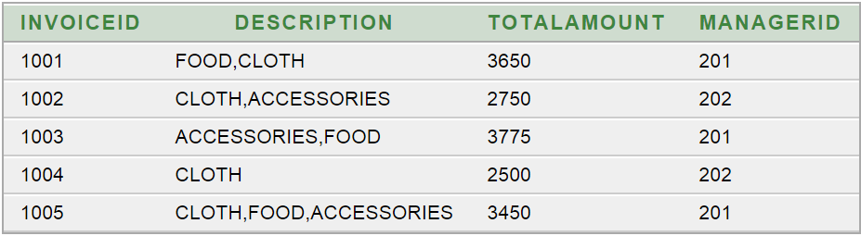

Purchase Table:

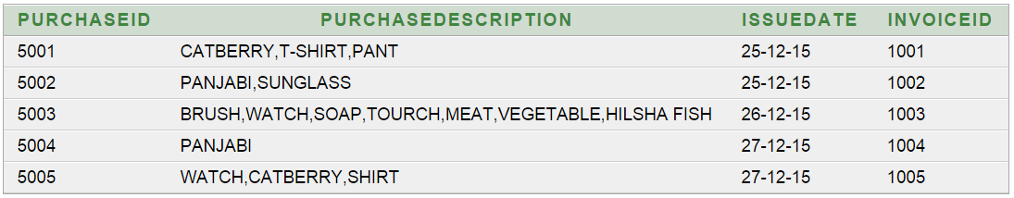

***VIEW***

1. Create a view which will show all bill details.

🡪 create view BILL_DETAIL as select invoice.invoiceid,purchasedescription,totalamount,issuedate from invoice,purchase where invoice.invoiceId=purchase.invoiceId

select * from bill_detail

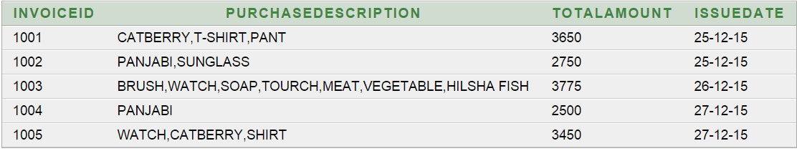

2. Create a view which will show the storename and categoryid of those products which have accessories id 703 or green color.

🡪 create view store_category_name as select s.storeName,c.categoryId from store s,category c where s.storeId=c.storeId and c.categoryId in((select categoryId from cloth where colorId=(select colorId from color where colorName='GREEN')),(select categoryId from accessories where accessoriesId=703))

select * from store_category_name

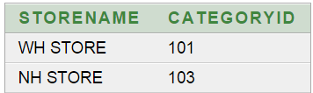

3. Create a view which will show details of thosmanager who recorded maximum invoice.

--> create view max_bill_manager as select * from manager where managerId=(select managerId from invoice group by managerId having count(*)=(select max(count(*)) from invoice group by managerId))

select * from max_bill_manager

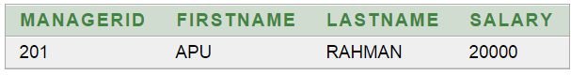

4. Create a view which will show all details of customers.

🡪 create view customer_detail as select * from customer

select * from customer_detail

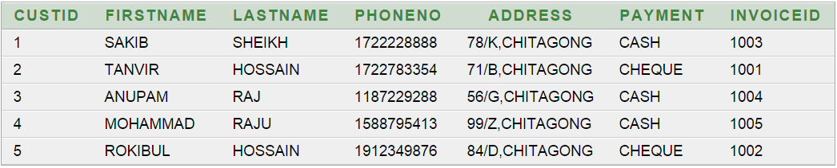

5. Create a view of all salesman on the ascending order of salary.

🡪 create view salesman_detail as select * from salesman order by salary asc

select * from salesman_detail

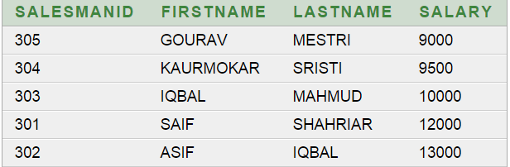

*QUERY*

1. Show details of the customer who spend maximum money to buy product.

--> select * from customer where invoiceid =(select invoiceid from invoice where totalamount = (select max(totalamount) from invoice))



2. Show purchase details of customers whose id is in 2 or 3.

--> select * from purchase where invoiceid in ( select invoiceid from invoice where invoiceid in ( select invoiceid from customer where custid in (2,3)))

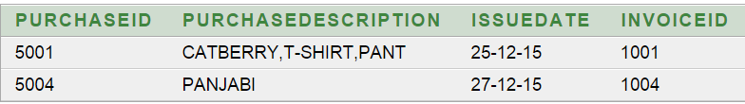

3. Show details of food which has 3rd maximum price.

--> select * from food where price=(select max(price) from food

where price<(select max(price) from food

where price<(select max(price) from food)))



4. Show all accessories items on the ascending order of price.

--> select * from accessories order by price asc

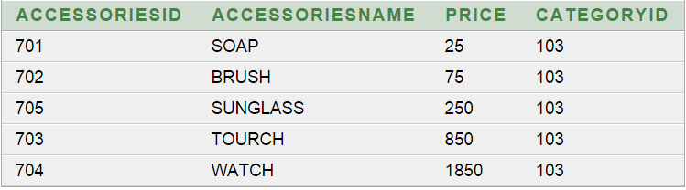

5. Show details of all invoices with their purchase id and issuedate.

-->select invoice.*,purchase.purchaseid,issuedate from invoice,purchase where invoice.invoiceId=purchase.invoiceId

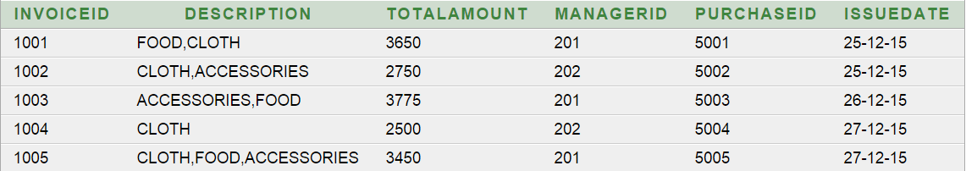

6. Show the total amount of all employee’s salary.

--> select sum(s.salary)+sum(m.salary)"TOTAL SALARY OF EMPLOYEE" from salesman s,manager m

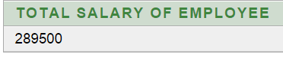

7. Show details of manager who recorded maximum invoice.

--> select * from manager where managerId=(select managerId from invoice group by managerId having count(*)=(select max(count(*)) from invoice group by managerId))

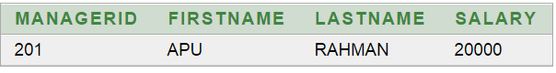

8. Show details of those accessories items which have greater price than average of all accessories items.

->select * from accessories where price>(select avg(price) from accessories.

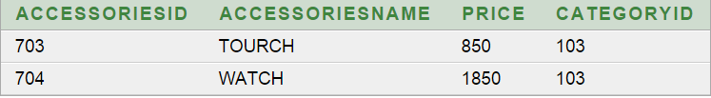

9. Show maximum price of salesman.

--> select max(salary)"Maximum Salary" from salesman

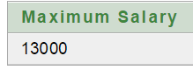

10. Show the storename and categoryid of those products which have accessories id 703 or green color.

-->select s.storeName,c.categoryId from store s,category c where s.storeId=c.storeId and c.categoryId in((select categoryId from cloth where colorId=(select colorId from color where colorName='GREEN')),(select categoryId from accessories where accessoriesId=703))

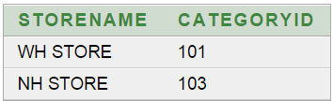

*Project Learning Experience:*

In this project we learned how to make a table, relationship diagram and how to present every table clearly. We can add new features as and when we require. We have learned about primary key and foreign key, junction table and also know about 1nf, 2nf and 3nf.

*Software Scope and future plan:*

This project was developed to fulfill some requirement; however there are lots of scope to improve the performance of this management system.Those are the area of database interface, database performance.

There are many features like linking and integration of other database. Integration with super shop database through web services. We can also develop data security and system security. Our future plan is to include online shopping in our super shop system.

***Problem faced****:*

During creation of this database system we faced some problems. We used oracle 10g software and sometime its shows server error for why we failed to login. To complete database relationship diagram clearly showing every table, attributes and data type was tough task to done. We faced some problem while creating table. We also faced some problem to find primary key and foreign key. After acquiring 1nf, 2nf and 3nf it was easy to find foreign key. For some simple mistake it was difficult to create the required table like using wrong character or using the same name. But we tried our best to make this database perfect. We have learned from our mistake and we have also gained knowledge from our project and we will apply it in our future project.